**Project Setup**

Following are the steps to setup and run the project:

**Creating the build:**

1. Clone the repo from <https://github.com/reactkart/springmicro.git> which has example directory containing micro services projects.
2. Import the all five micro services project in eclipse as a maven project.
3. Build all five project with maven which will generate the jar files in there respective target folders.

Note: Following deployment is done on Centos 7.

**Deploying the build using docker:**

1. Make sure docker and docker-compose is installed in your env.
2. Open terminal in ‘example’ directory.
3. Run the following commands:
   1. sudo chmod 777 setup.sh
   2. docker-compose up
4. Wait until all services are up then navigate to following url:
   1. <http://localhost:8084/swagger-ui.html>

**Deploying the build using kubernetes:**

1. Make sure you have a kubernetes cluster and kubectl setup in your env.
2. Open terminal in ‘example’ directory.
3. Run following command:
   1. docker-compose build
   2. kubectl apply -f k8s/
4. Wait until all pods and service are up.
5. Navigate to following URL:
   1. <http://<cluster>-IP>:30115/swagger-ui.html

**Setting up minikube and deploying build on it:**

1. Download latest minikube and kubectl for linux from following URL:
   1. <https://github.com/kubernetes/minikube/releases>
   2. https://storage.googleapis.com/kubernetes-release/release/v1.18.0/bin/linux/amd64/kubectl
2. Open the terminal in the downloaded location and run the following command:
   1. sudo mv minikube-linux-amd64 /usr/local/bin/minikube
   2. sudo mv kubectl /usr/local/bin/kubectl
   3. sudo chmod +x /usr/local/bin/minikube
   4. sudo chmod +x /usr/local/bin/kubectl
3. Make sure docker and docker-compose is installed in your env.
4. Run the following command to start the minikube:
   1. minikube start --cpus 4 --memory 9000 --disk-size=10g --driver=docker *(Update the command as per your VM specs)*
   2. minikube dashboard *(this will open the dashboard on default browser)*
5. Open terminal in ‘example’ directory.
6. Run the following commands:
   1. eval $(minikube -p minikube docker-env)
   2. docker-compose build
   3. kubectl apply -f k8s/
7. Navigate to dashboard on browser and verify all pods are up.
8. Run this command in terminal to get cluster IP :
   1. minikube ip
9. Navigate to following URL:
   1. <http://<cluster>-IP>:30115/swagger-ui.html

Setup keycloak:

1. Navigate to : <http://<cluster>-IP>:30114
2. Login using admin/admin
3. Navigate to Clients > test-client > Credentials > Click ‘Regenerate Secret’

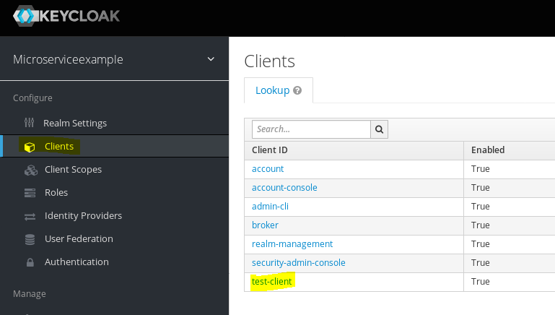

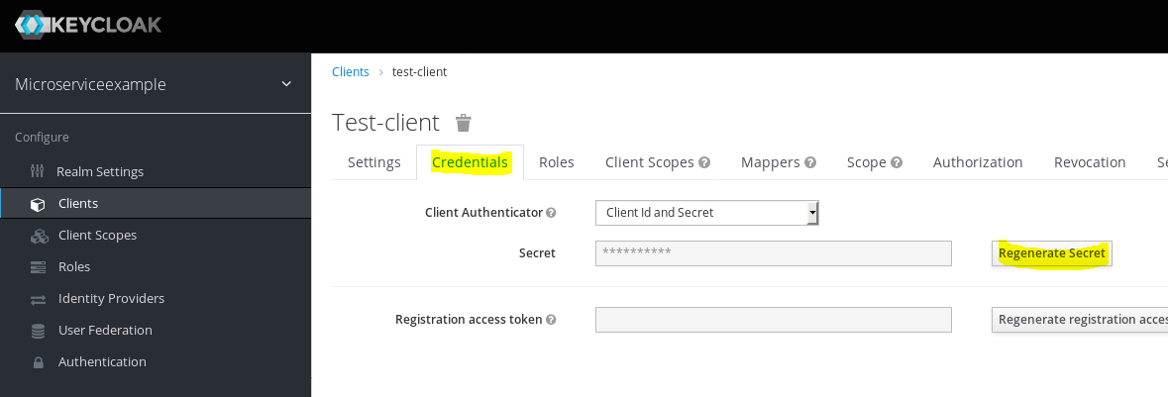

1. Go to Users and then create a user

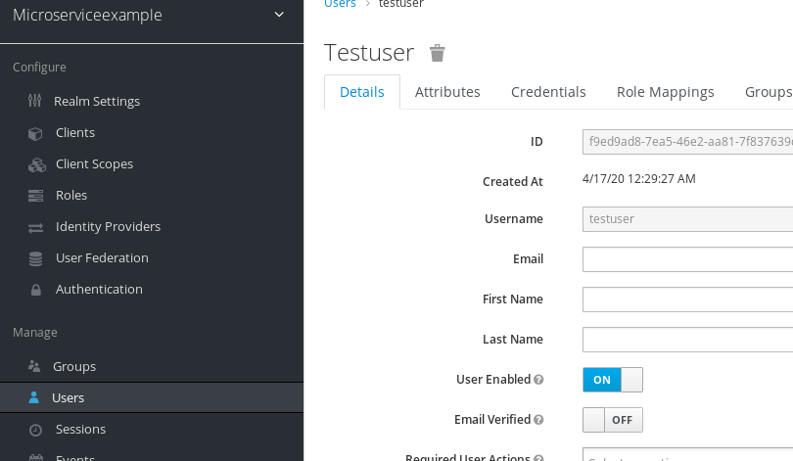

1. Go to Role Mapping and assign all client roles to this user:

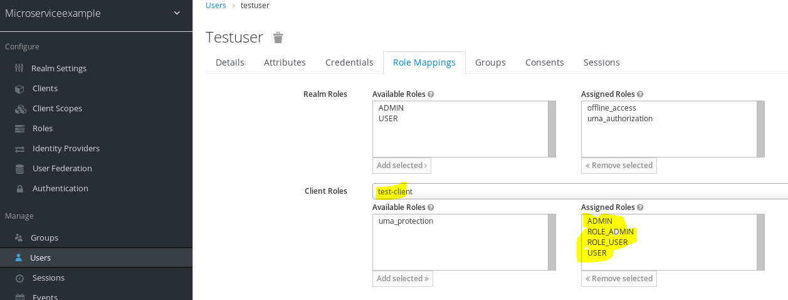

1. Go to Credentials and set a password for this user.
2. Run the following command to get the access token:
   1. curl -X POST -d 'grant_type=password' -d 'username=<username>' -d 'password=<password>' -d 'client_secret=<secret key generated above>' -d 'client_id=test-client' http://<cluster-IP>:30114/auth/realms/microserviceexample/protocol/openid-connect/token